Michigan Youth in Government

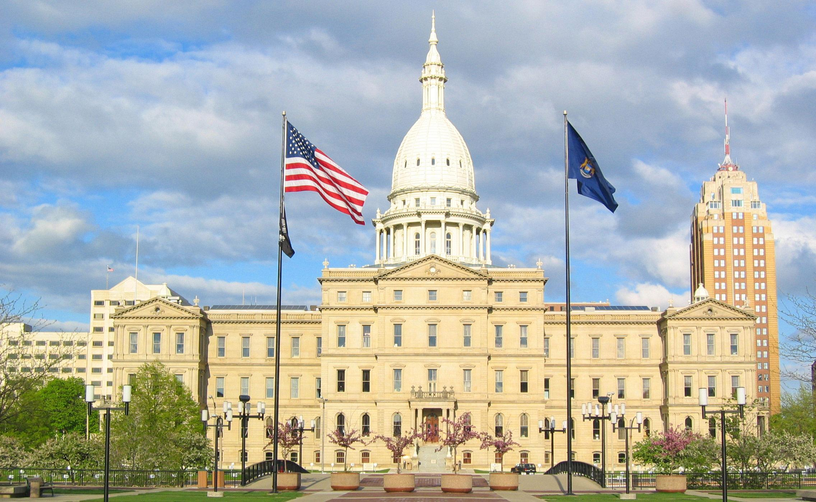

What is Youth in Government?

Youth in Government (YIG) is a club at Mason High School that is run in conjunction with the YMCA of Michigan. The purpose of this program is to develop a dedication to the values of democratic government and leadership within our students. The highlight of this club is a conference in the spring during which YIG students from all over Michigan travel to the capitol building in Lansing and run a mock government. Students spend days debating their own bills, often on the floor of the Michigan legislature. Students participate as legislators, but they could also choose to participate as lobbyists, in the press corps, or in a mock trial competition.

What do we do?

The activities of Mason Youth in Government are:

--A fall training conference
--Meetings throughout the school year to write bills and prepare for the spring conference
--A 4-day spring conference in Lansing

Fall training Conference

On Friday, October 26, we will travel to Central Michigan University to attend the fall training conference. This one-day event is designed to prepare and inform students and advisors about the Lansing experience. The day includes workshops in all program areas, campaigns, and the election of district candidates. We will leave from and return to the high school during the school day. The cost of the fall conference is $30, which is credited to the cost of the Spring Conference.

YIG Meetings

Last year we met about every other week to brainstorm, write and revise bills, learn about parliamentary procedure, and make other preparations for the spring conference. It is not required that you make it to all of the meetings, but the more meetings you make it to, the better your experience at the spring conference will be.

Spring Conference

From February 28 to March 3, our delegation will attend the MYIG conference in Lansing. Part of the conference is spent at the Kellogg Center in committee meetings, and part is spent at the capitol building, when students will run their mock government in the House and Senate chambers. Year after year, students report that this learning experience at our state’s capitol is unlike anything that could be taught in the classroom. The lessons about civics and government are enriched by interacting and socializing with students from all over the state!

What are the benefits of Youth in Government?

- Enhances the leadership qualities in our student delegates.
- Promotes honesty, respect, and responsibility.
- Places our students in an environment with people of diverse communities from around the state of Michigan with ideas about the role of government that might be different from their own.
- Teaches our students to respectfully campaign and defend their beliefs.
- Students learn the inner workings of our state government as acting members during the conference.

The Cost of the Program

This is a great program, but there is a cost, as the spring conference involves a hotel stay, charter bus transportation between the hotel and capitol, and YMCA participation fees. Here is the cost:

Fall Conference Fee $30
1st Spring Conference payment – due in November $100
2nd Spring Conference payment – due in January $275
______________________
$405

The Michigan Youth in Government Alumni Association provides funding for delegate financial assistance. Financial assistance is awarded based on need; the total awarded will range from $50 to $150 depending on the student's need and the conference price. You can apply for this assistance at the Michigan Youth in Government website.

For more information about this great program, feel free to:

--E-mail Dan Guysky (advisor) at guyskyd@masonk12.net

--visit the Michigan Youth in Government website at www.myig.org

