Creating a new account:
- Go to www.turnitin.com and select Create Account in the upper right hand corner
- Under Create a New Account, select Student
- Enter the required information and click I Agree - Create Profile at the bottom of the page
- IMPORTANT! If you have a Turnitin account already, please do NOT create a new account! Instead, select Retrieve Password or ask your teacher or Mrs. Sandel (librarian) for help

Enrolling in a Class:
- Go to www.turnitin.com and log in to your account
- 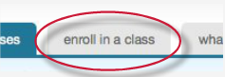If you forgot your password, do NOT create a new account - select Retrieve Password or ask your teacher or Mrs. Sandel (librarian) for help!
- Click on the Enroll in a Class tab on the student home page
- Enter the class ID and enrollment password (case sensitive) for the new class
- Click submit to enroll in the class and add it to the student user homepage

Class/Hour | Class ID | Enrollment password
U.S. History – 1st hour | 9341877 | Guysky1
U.S. Civics – 3rd hour | 9354551 | Guysky3
U.S. History – 5th hour | 9341905 | Guysky5

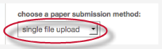Submitting a paper by single file upload:
- Log in to your account and click on the appropriate class name
- Click on the Submit button to the right of the assignment name
- Select single file upload from the choose a paper submission method pull down menu
- Click the Browse button and select the file to upload. Fill the submission title field with the paper name
- Click upload to upload the file. A status bar will appear displaying the upload progress
- Review the preview panel. This is a text-only version of the paper being uploaded. Confirm that it is the correct version of the file to send
- Click submit ***Warning! If you do not click submit your paper will not be uploaded!***
- If you submit the incorrect paper or something goes wrong, contact your teacher or Mrs. Sandel for help

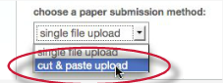
Submitting a paper by copy and paste:
- Log in to your account and click on the appropriate class name
- Click on the Submit button to the right of the assignment name
- Select cut & paste upload from the choose a paper submission method pull down menu
- Fill in the submission title field and copy the text from the text document. Do NOT manually type an entire paper into the copy/paste field. It might time-out and you will lose any information you typed!
- Click submit ***Warning! If you do not click submit your paper will not be uploaded!***
- If you submit the incorrect paper or something goes wrong, contact your teacher or Mrs. Sandel for help

Originality Check:
Depending on how your teacher has the assignment configured, you may be able to view your originality report soon after you submit an assignment. The Originality Report provides a summary of matching or similar areas of text found in a submitted paper.

When an Originality Report is available to be viewed, an icon is placed in the Originality Report column of the student class portfolio page. If the Originality Report has not finished generating, it will have a grayed out icon placed under the Originality Report column of the student class portfolio page. Check back in 5-10 minutes to view the completed Originality Report.

The Originality Report icon shows a percentage and a corresponding color indicating where this percentage falls in terms of matching content.

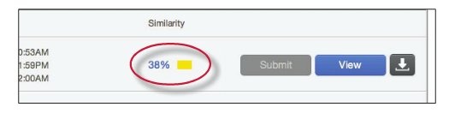

Once the Originality Report has been generated, clicking on the percentage/color will bring up the full Originality Report. Remember, direct quotations, citations, or bibliography areas of the paper are not automatically excluded! The percentage/color does NOT necessarily indicate plagiarism.
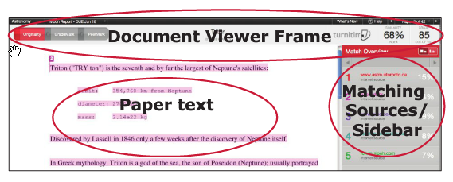

Need help?
If you need assistance using Turnitin.com, see your teacher or Mrs. Sandel in the library or visit http://www.turnitin.com/en_us/training/student-training for great videos and tutorials

